**Sylvia Chang**

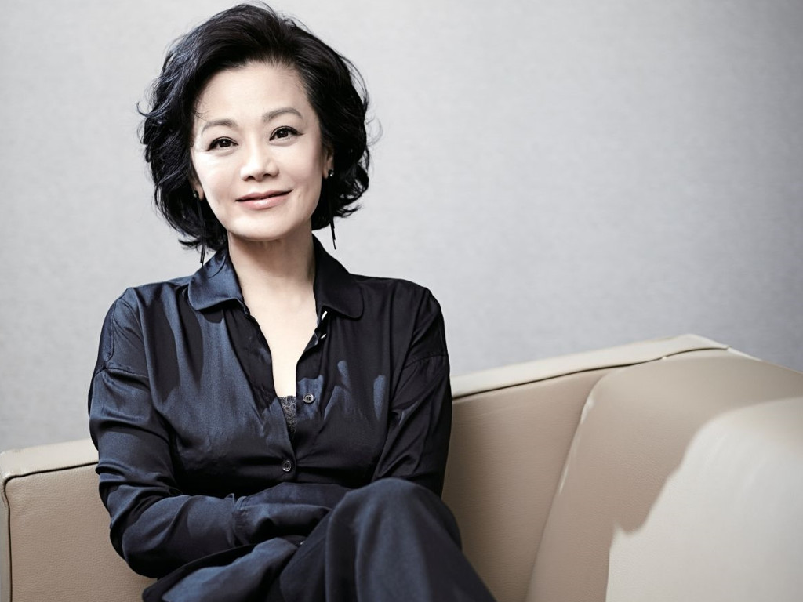

Sylvia Chang Ai-chia was born 65 years ago before the digital revolution in the Film Industry, but when one sees her today at helm of affairs in the film industry as a producer and director, it’s hard to believe she is not a digital native. Born on 21 July 1953 in Chiayi, Taiwan, Sylvia Chang has spent over four decades building a career in the movie industry as an actress, writer and singer, and lately as a producer and director.

She will not hesitate to tell you that the greatest honours accorded her were when she was selected to be a member of the jury at the Berlin International Film Festival in 1992 and 1994 respectively..

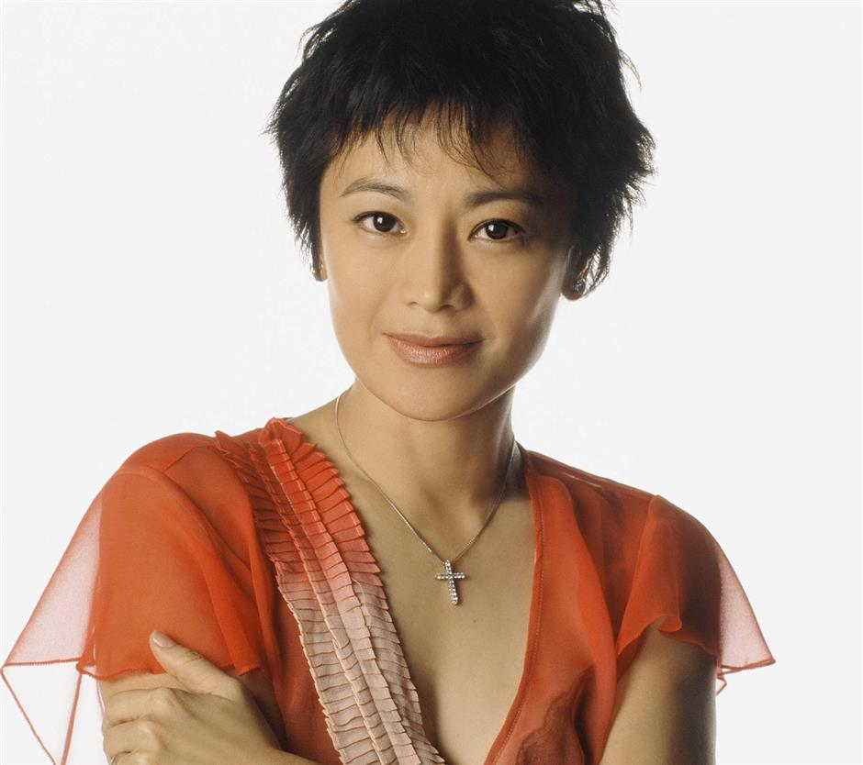

She dropped out of school at the age of 16 to pursue a career in entertainment at a local radio station as a DJ. Within a year she was able to move higher up the ladder into television entertainment and at the age of 18 secured the lead role in her first film. Thereafter, her performances have facilitated the building of a diversified career that has seen her rise to the very top whether in acting, singing, writing, producing or directing.

She is considered by many in the industry as one of Hong Kong’s greatest artiste. She has been able to combine family life and a career successfully. She is married to Wang Ching Hung, a businessman.

Sylvia Chang’s finest moments include the two times she received the best actress Award at the Golden Horse and Hong Kong Film Awards respectively. However, her real life worst moment has got to be in July 2000 when one of her sons was kidnapped for a ransom by gangsters. Luckily, the police were able to rescue him from the mob.

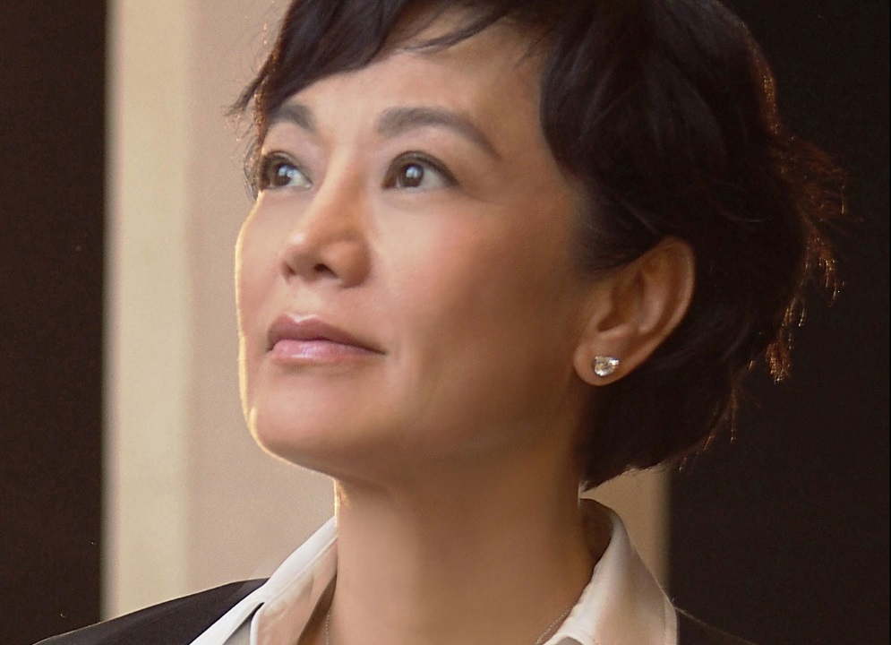

Outside of her career in the entertainment industry, she is an ambassador for World Vision International, a non-governmental organization engaged in the charitable work of fighting poverty and starvation across the globe. She has been involved for over 20 years and has contributed a lot to raising awareness about malnutrition in third world countries such as Ethiopia and Eritrea.

She made clear it on several occasions that she is driven by her belief that "there are so many good things in the world, and so many horrible things, but all these things are for all of us to take responsibility for".

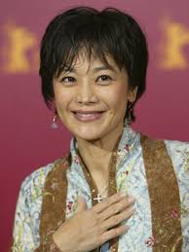

Chang was highly prolific as a movie-star in the early part of her career which spanned between 1976 and 1986. She appeared in a total of 57 films including highly acclaimed blockbusters of Hong Kong cinema, such as the *Aces Go Places* series of the 80s and screwball comedy *Shanghai Blues* (1984) by Tsui Hark.

Her talents and hard work in the film industry paid off with Hong Kong Film Awards Best Actress in 1987 for her role in *Passion* andin 2002 for her performance in *Forever and Ever.* She also won Best Screenplay award in her performance in *Tempting Heart* (2002). Other awards includes Golden Bauhinia Awards Best Actress in the *Forever and Ever* (2002) and Golden Horse Awards Best Actress in *My Grandfather* (1981) and 1986 *Passion* (1986)



She is quoted as saying "I really enjoyed the period working with Cinema City. The only aspect I didn't like was that they did too many sequels and the later films eventually lost the charm. But when I re-watch *Aces Go Places*, it still shows me how good commercial movies can be."

One of her uniqueness in the Hong Kong film industry is her ability to fit into diverse roles. She played roles that ranged from an innocent girl to a prostitute, from an oppressive government official to a kind and respected teacher and from a drunkard to a family woman.

She appeared in her first film *The Tattooed Dragon by* Wei Lo in 1973 at the age of 18. Sylvia Chang’s latest film is *Murmur of the Hearts*. It can be seen in this film that she is now trying to shed her movie star image to one of a prolific writer and director.

She retorted: "I'm the only film director who still has to do her make-up and hair at every promotional event. It's very troublesome - and my team always makes fun of me about it - but what can I do? It's because when other people look at me, they still think of me as a movie actress who happens to be doing a director's job."

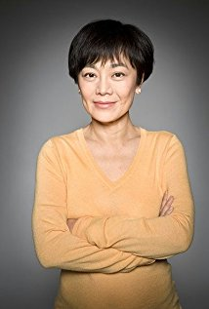

At 65, for an actress, she is in an advanced age and can be excused for trying to transition into a role behind the camera. In particular she is bent on breaking the male-dominance in the Hong Kong film industry.

According to Clarence Tsui who is a well-known film editor, Chang said in an interview that "I still think Hong Kong's film industry is male-dominated. There aren't many male filmmakers who would write scripts for women". She has been busy of late trying to explore how gender balance can be entrenched in the industry.